New Installations

Upgrades with a Physical CD

Upgrades with an update-package.sh File

# New Installations

WARNING: This process will completely erase the system's hard drive.

1. Boot from the CD.

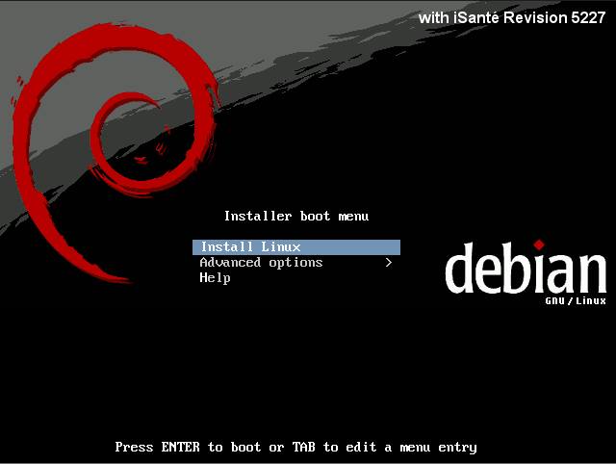

2. Select "Install Linux" from the boot menu.

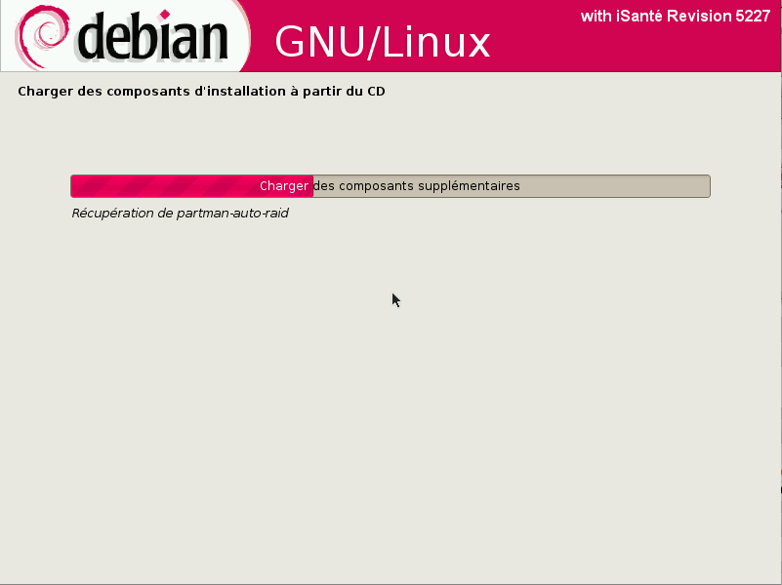

3. The installer will ask if it is okay to format the system's hard drive, install Debian and reboot the machine (10-20 minutes).

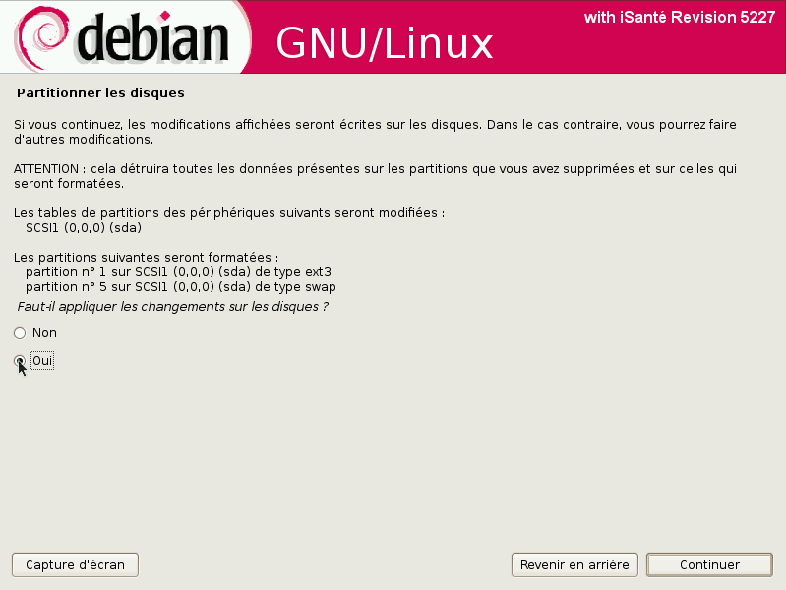

4. During the first boot you will be asked a few questions about dbSite and siteCode values for the installation.

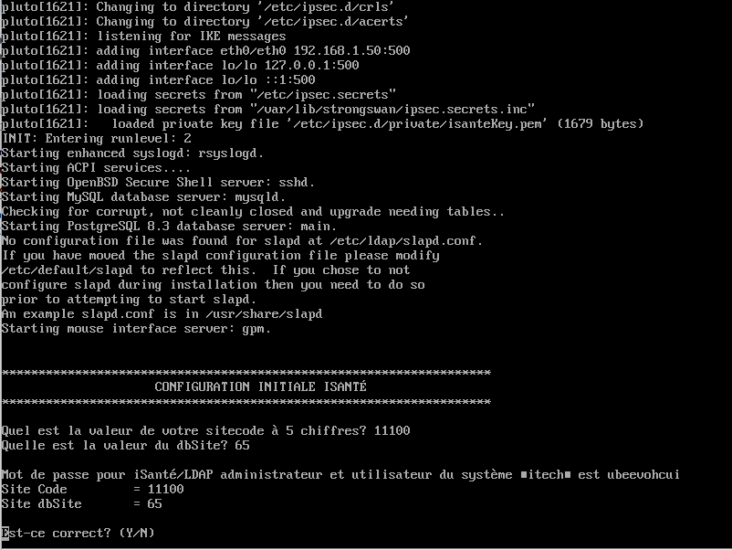

After that the system will be fully setup and ready to use. The console screen is displayed:

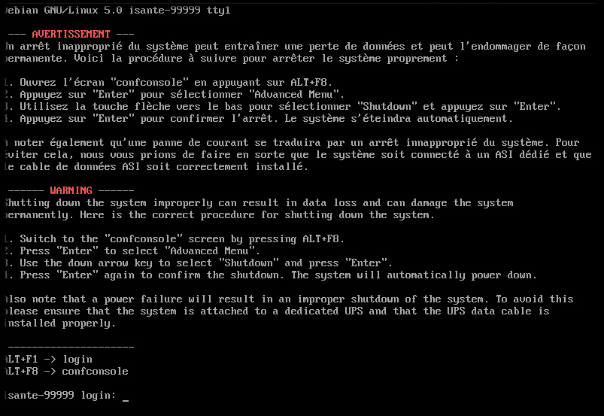

Notice that since the password for the itech user is randomly generated, a reference on the console reminds the user that ALT+F8 will switch the user to the configuration console, which provides the password value:

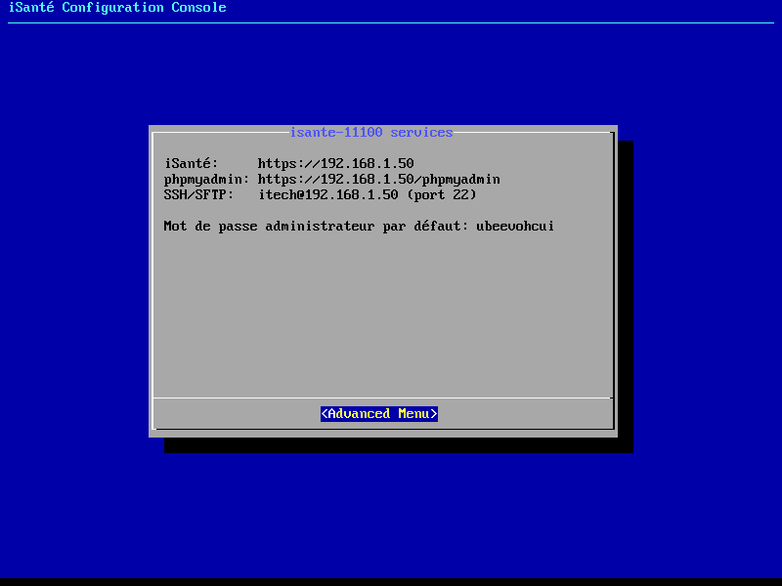

# Upgrades with a Physical CD

1. Boot the machine normally, logging in as the itech user

2. Insert the CD and issue the command `mount /cdrom`

3. Run the command `sudo sh /cdrom/simple-cdd/upgrade`

4. A prompt will show the version number of the currently installed version and the version being upgraded to. Press ENTER here to proceed with the upgrade. (30-45 minutes)

5. The system may reboot when the upgrade is done. You will need to remove the CD at this point.

If you have the .iso image on a hard drive or USB drive you can use this alternative step 2:

2. Issue the command `sudo mount <path_to_.iso_image> /cdrom -o loop`

# Upgrades with an update-package.sh File

WARNING: This method requires an active Internet connection.

1. Boot the machine normally and log in as the itech user.

2. Copy the update-package.sh file onto the system.

3. Issue the command `sudo sh <path_to_update-package.sh_file>`

4. If additional system software is required for this upgrade a prompt will appear saying what needs to be installed. Pressing ENTER here will download the needed software from the central Debian repository. The upgrade will abort if there is no Internet connection.

5. A prompt will show the version number of the currently installed version and the version being upgraded to. Press ENTER here to proceed with the upgrade. (30-45 minutes)

6. The system may reboot when the upgrade is done.